Mastodon Sentiment Analysis: Tracking Discourse on Major AI Brands

1. Introduction
Public discourse around large-language-model brands has become a meaningful indicator of how new AI products are received. This project asks a focused question: how does the Mastodon community talk about four widely-recognized AI brands — ChatGPT, Claude, Gemini, and GitHub Copilot, and do those conversations differ in sentiment from one brand to another?
Mastodon was chosen as the data source because its open access API permits programmatic collection of public posts without commercial restrictions. Data was collected from fosstodon.org, a tech-leaning instance with active discussion of AI tools. The project pairs an automated data engineering pipeline (Apache Airflow, PostgreSQL storage) with two sentiment-analysis methods (rule-based VADER and machine learning RoBERTa transformer for validation).
“Across over 10,000 posts collected over the last 3 months, Gemini received the most positive average sentiment, while ChatGPT showed the highest share of negative discussion.”

2. Data Source and Methodology
Posts were collected via Mastodon's timeline_hashtag endpoint on fosstodon.org. Four AI brands were tracked using nine total hashtags: chatgpt, openai, gpt4 (ChatGPT); claude, anthropic (Claude); gemini, bard (Gemini); githubcopilot, copilot (Copilot). These brands cover both general-purpose AI assistants and one AI coding tool.
Each Airflow run executes four stages: collect (fetch up to 40 posts per hashtag, English-language only), clean (strip HTML, URLs, and @mentions; filter posts under three words), score (apply VADER to compute compound, positive, neutral, and negative scores), and store (insert into PostgreSQL with ON CONFLICT DO NOTHING for deduplication on post_id). Sentiment categories are derived from the compound score: positive (≥ 0.05), negative (≤ -0.05), or neutral. The pipeline runs every 15 minutes.
Beyond live collection, two complementary scripts populated the dataset: backfill.py paginates each hashtag backward via max_id to retrieve up to 90 days of historical posts and ml_score.py applies the Robustly Optimized BERT transformer to every row, writing per-class probabilities into ml_* columns alongside VADER's scores.
AI Tool (topic) | ChatGPT | Claude | Gemini | Copilot
Hashtags | #chatgpt  #openai  #gpt4 | #claude  #anthropic | #gemini  #bard | #githubcopilot  #copilot

3. Pipeline Architecture
The full stack runs locally under Docker Compose: an Apache Airflow cluster (scheduler, Celery worker, web UI) coordinated through Redis, PostgreSQL for both Airflow's metadata and the project's sentiment_data table, and Grafana for live visualization. The architecture is summarized in Figure 1.
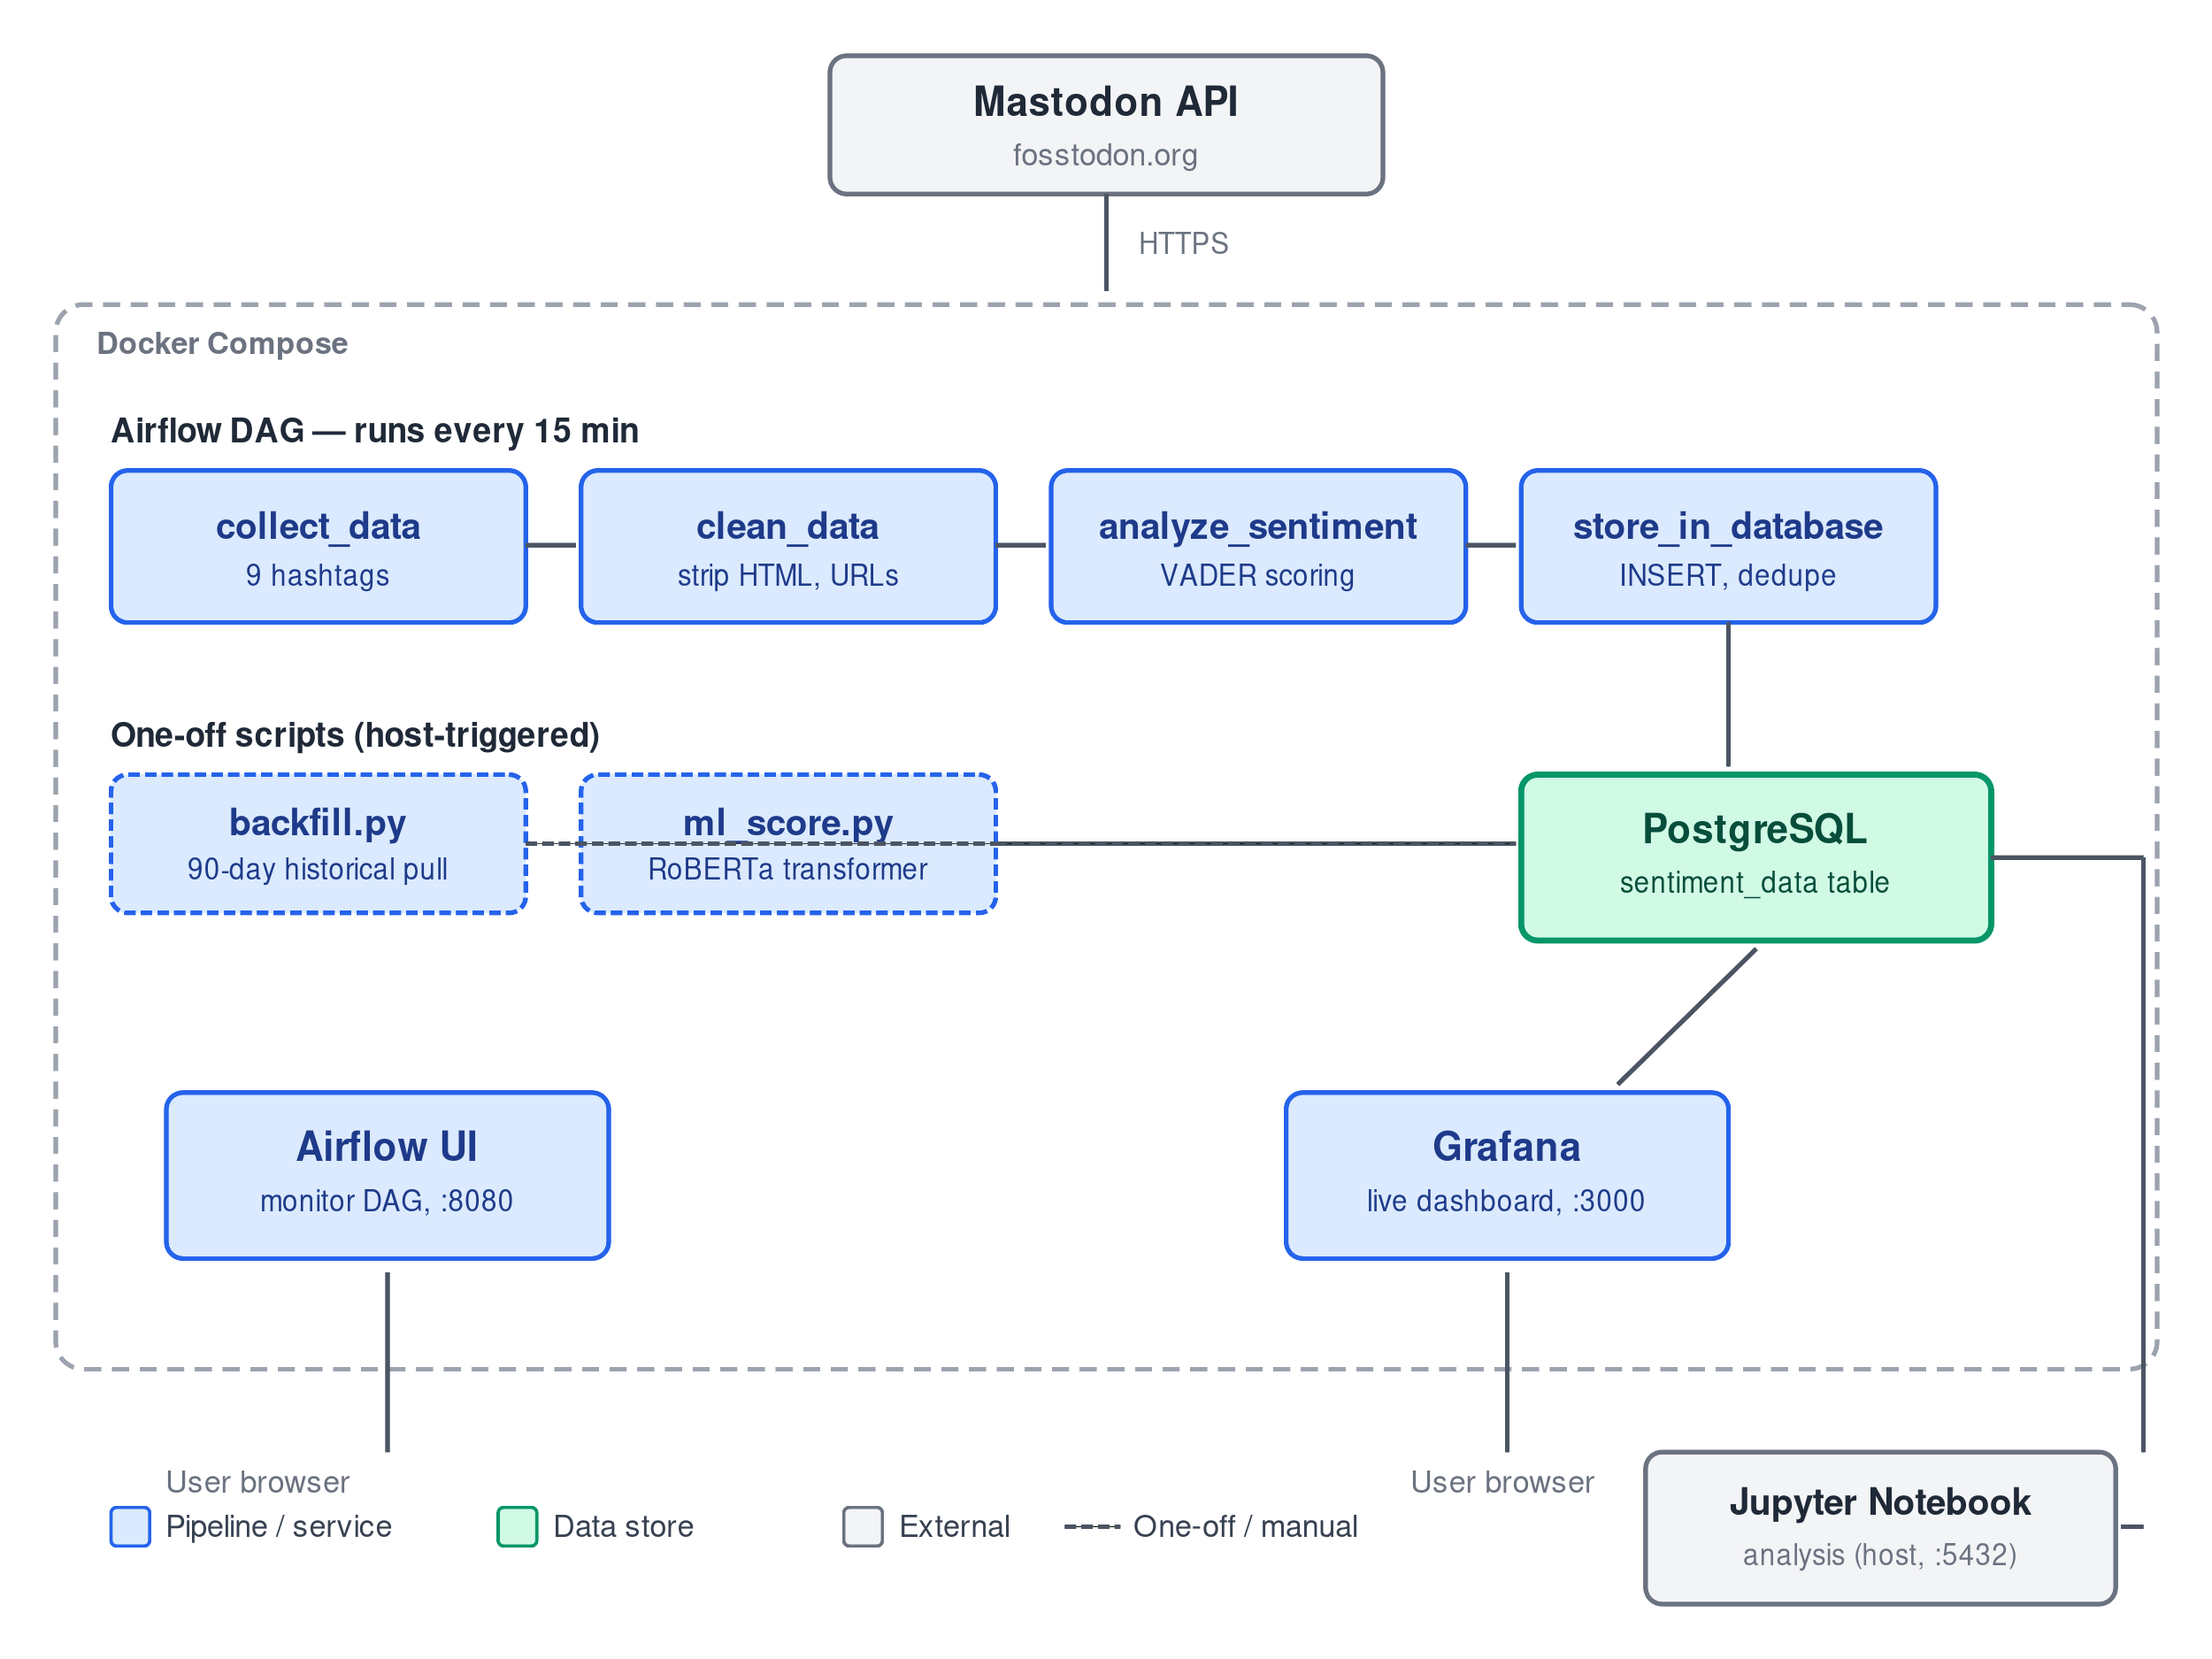
Two design choices are worth highlighting. First, one-off historical work (the 90-day backfill and the transformer scoring of existing rows) is implemented as standalone scripts rather than additional DAGs. This keeps the live pipeline narrow and predictable while letting expensive batch operations run on demand. Both scripts are idempotent — they use ON CONFLICT for inserts and IS NULL filters for updates — so they can be re-run safely after a partial failure. Second, the analysis layer is split: Grafana provides a live operational dashboard (auto-refreshing every minute, directly readable on a host browser at localhost:3000), while a Jupyter notebook on the host pulls from the same PostgreSQL instance for deeper ad-hoc analysis and for figures intended for this report.

4. Findings

4.1 Sentiment ranking by AI brand
Across the dataset, the four AI brands ranked by mean VADER compound sentiment as follows:
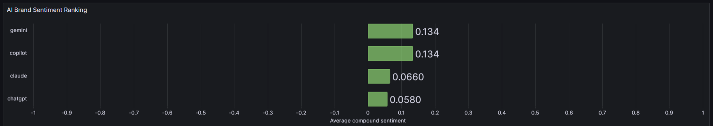
The corresponding distributions of positive, neutral, and negative posts per brand are shown:
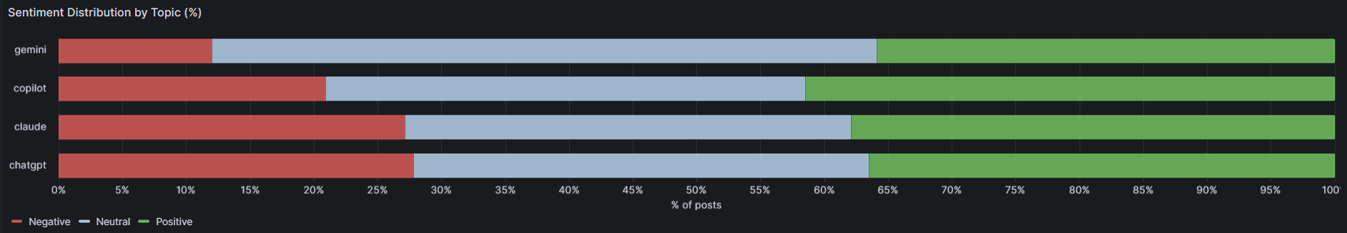
The rankings are somewhat tight between the 4 topics. While Copilot has the highest positive sentiment, Gemini ranks higher with the combination of positive and neutral. Claude seems to be the most polarizing since it has a high negative and positive sentiment with the smallest neutral sentiment.

4.2 Method validation: VADER vs. transformer
To verify that findings did not depend on any single sentiment-scoring tool, posts were independently re-scored with a BERT transformer model. The two methods agreed on the category label for 57% of posts and produced a similar ranking of AI brands by mean sentiment.
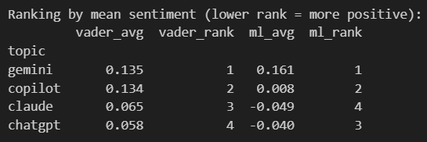
The models agreed on Gemini and Copilot ranked 1 and 2 and differed on Claude and ChatGPT ranking 3 and 4 respectively. This confusion matrix and bar plot show the comparison of the 2 models.
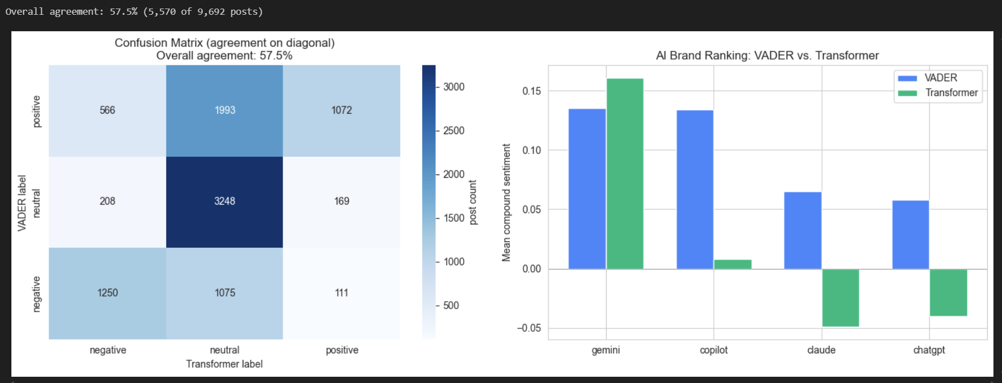

5. Discussion, Limitations, and Future Work
The findings should be read with several limitations in mind. The data source fosstodon.org is a small, technically oriented Mastodon instance whose users are not representative of the public. Sentiment captured here reflects the views of a tech-leaning audience. The fixed hashtag set captures only posts where users explicitly tagged the brand; untagged discussions of these tools are absent from the dataset. Lexicon-based sentiment analysis (VADER) is known to struggle with sarcasm, technical jargon, and context-dependent meaning; the transformer comparison in Section 4.2 partially addresses this by surfacing where the two methods disagree.
Several directions would extend this work. The scope of data could be increased by using a different Mastodon. This could broaden the audience demographics, but it requires schema changes to ensure no duplication based on post_id. Hand-labeling a sample of 100-200 posts would allow direct accuracy comparison of VADER and the transformer against ground truth, rather than the agreement-rate framing used here. Tracking additional brands (notably newer developer-facing tools such as Cursor) would strengthen the comparison if accompanied by a matching reframe of the project's scope. To continue the methodology, comparing discourse on the same brands across different platforms such as Reddit or Twitter would help separate brand-level sentiment from platform-level audience effects.

